**Sprint 1 report**

Team name:

Break-It-Down

Scrum master:

Mariam Heikal 40-5263

Team members:

1. Janna Elghabaty 40-1773
2. Lina Shawky 40-1685
3. Eman Essam 40-1215
4. Yasmin Mansy 40-2021
5. Shaza Elmorshdy 40-2244
6. Nourhan Mahmoud 40-1983
7. Reem Khaled 40-5007
8. Malak Rassem 40-3571
9. Abdelrahman Nour 40-5860

Work flow:

* We met on Thursday 21/2/2019 to narrow down the user stories and discuss which user stories will be implemented in this sprint
* The stories were distributed among the team members based on the points
* The team member started working on the stories starting from Tuesday 26/2/2019 until Thursday 28/2/2019
* The team gathered on Thursday 28/2/2019 to make sure that everything is working correctly and that the flow of the project is correct
* On 3/2/2019 we started integrating the folders together and merging our commits

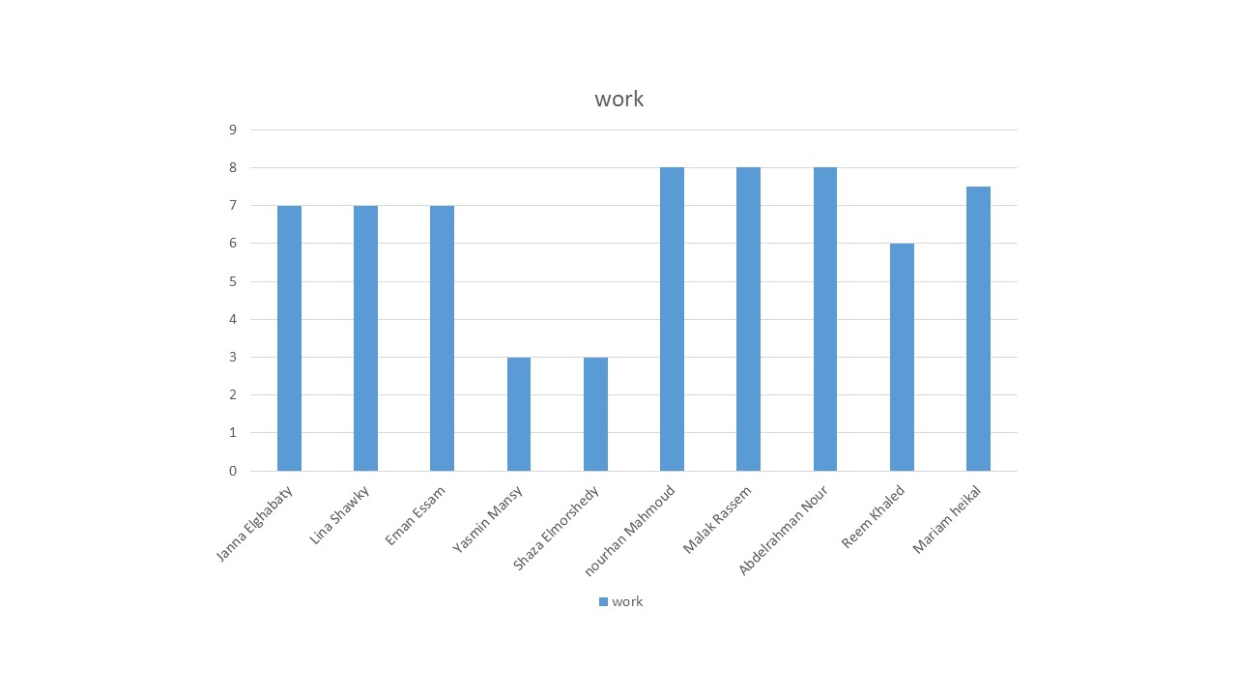Team member’s velocity chart:

Team’s total velocity:

Velocity= (­­7+7+7+3+3+8+8+8+6+7.5)/10

Velocity= 6.45

Challenges:

* Pushing and pulling on gitbash
* Merging our work together